Simulation and Sensitivity Analysis of Chaotic Systems

Part A — Discrete Chaotic Systems

A.2 Logistic Map
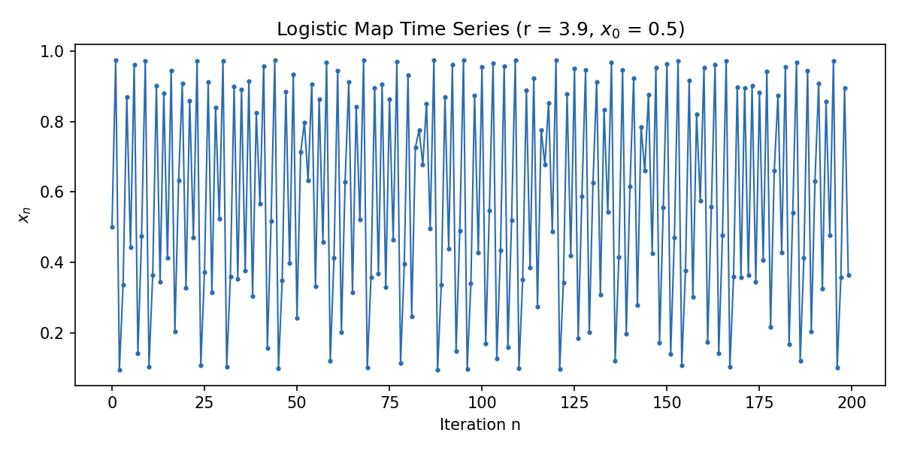

A.3 Hénon Map
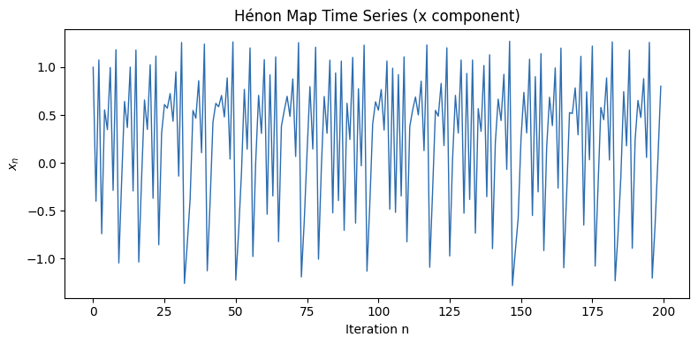

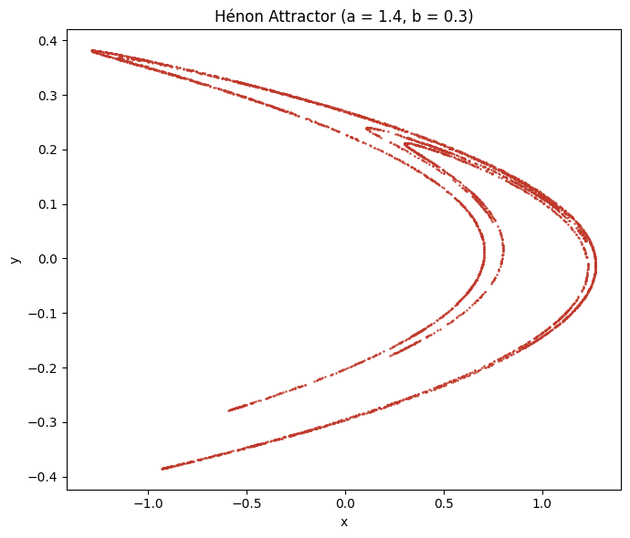

A.4 Bifurcation Diagrams
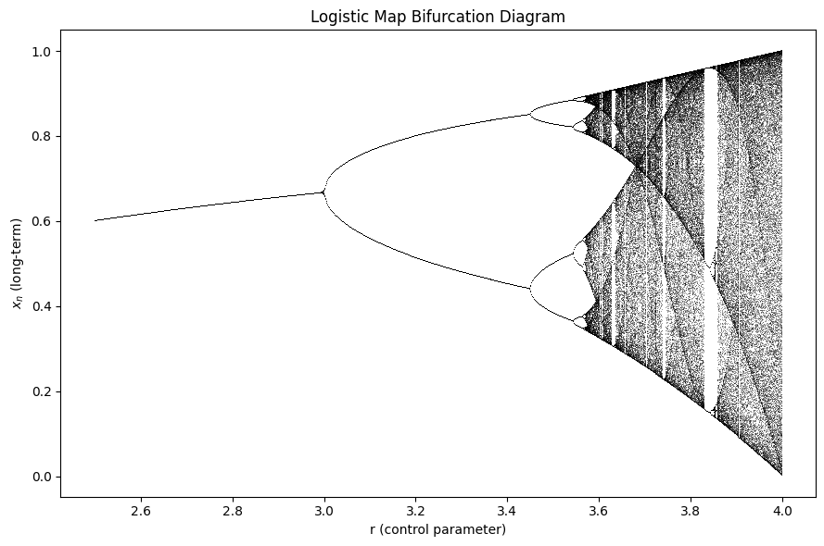
The logistic map bifurcation diagram shows how the behavior of the system changes as the value of r increases. At first, the system settles at one stable value, but as r becomes larger, it starts repeating between multiple values before eventually becoming chaotic. Even in the chaotic region, there are small areas where the system becomes periodic again.
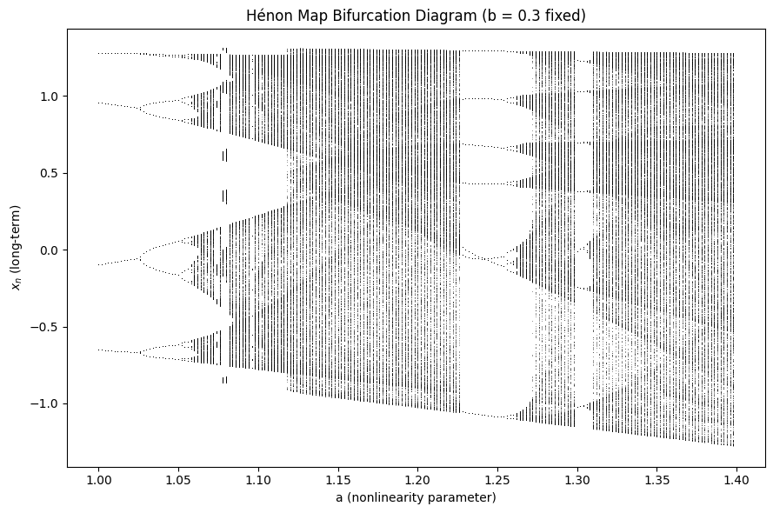
The Hénon map bifurcation diagram shows how changing the parameter a affects the long-term values of x. As a increases, the system changes from stable behavior to periodic motion and finally to chaotic behavior. The diagram also shows that small changes in a can produce very different results.

Part B — Continuous Chaotic and Hyperchaotic Systems

B.2 Lorenz System
ẋ = σ(y − x), ẏ = x(ρ − z) − y, ż = xy − βz
Setting | Value
State variables | (x, y, z)
Parameters | σ = 10, ρ = 28, β = 8/3
Initial condition | (1, 1, 1)
Time step, dt | 0.01
Simulation length | T = 50
Solver | RK45 (SciPy solve_ivp, adaptive)
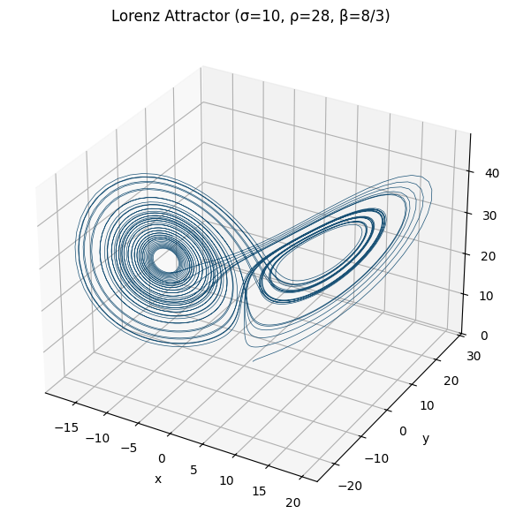
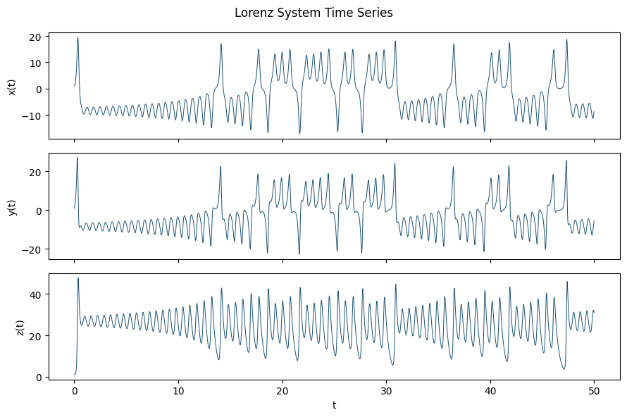The Lorenz attractor forms the well-known butterfly shape, showing that the system never follows the exact same path twice even though it is deterministic. The time-series plots show that the values of xxx, yyy, and zzz keep changing in an irregular way instead of settling to a constant value. This demonstrates the chaotic behavior of the Lorenz system

B.3 Rössler System
ẋ = −y − z, ẏ = x + a·y, ż = b + z(x − c)
Setting | Value
State variables | (x, y, z)
Parameters | a = 0.2, b = 0.2, c = 5.7
Initial condition | (1, 1, 1)
Time step, dt | 0.01
Simulation length | T = 300
Solver | RK45 (SciPy solve_ivp, adaptive)
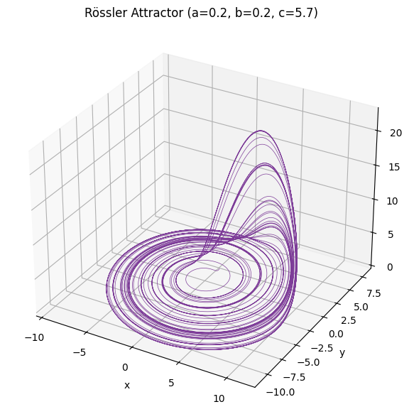
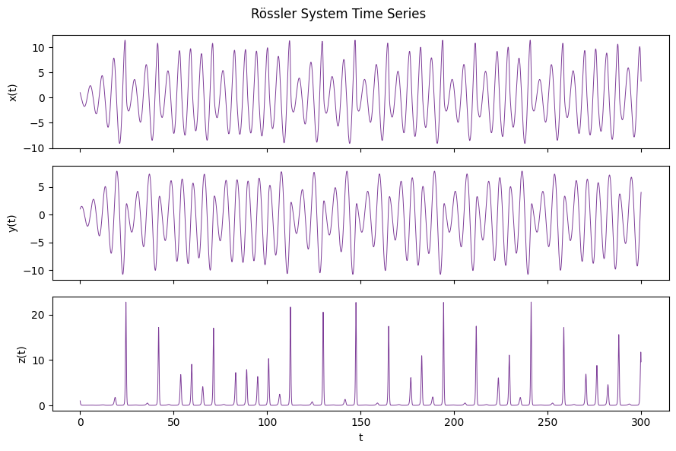The Rössler attractor has a spiral shape that repeatedly loops around before moving away again. The time-series plots show oscillating behavior with changing amplitudes, which indicates that the system is chaotic. Compared to the Lorenz system, the attractor has a simpler shape but still produces unpredictable motion.

B.4 Chen System
ẋ = a(y − x), ẏ = (c − a)x − xz + cy, ż = xy − bz
Setting | Value
State variables | (x, y, z)
Parameters | a = 35, b = 3, c = 28
Initial condition | (−0.1, 0.5, −0.6)
Time step, dt | 0.002
Simulation length | T = 50
Solver | RK45 (SciPy solve_ivp, adaptive)
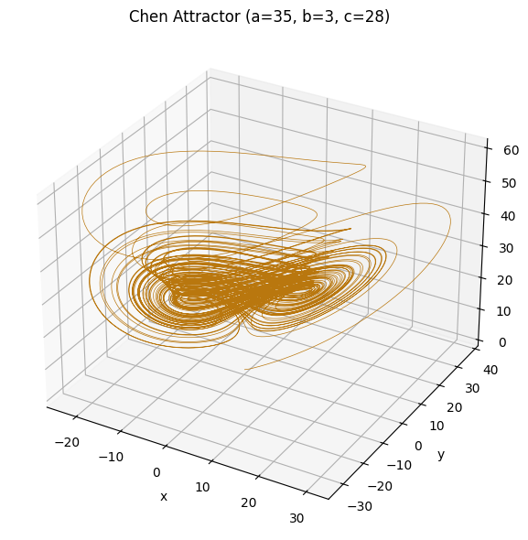
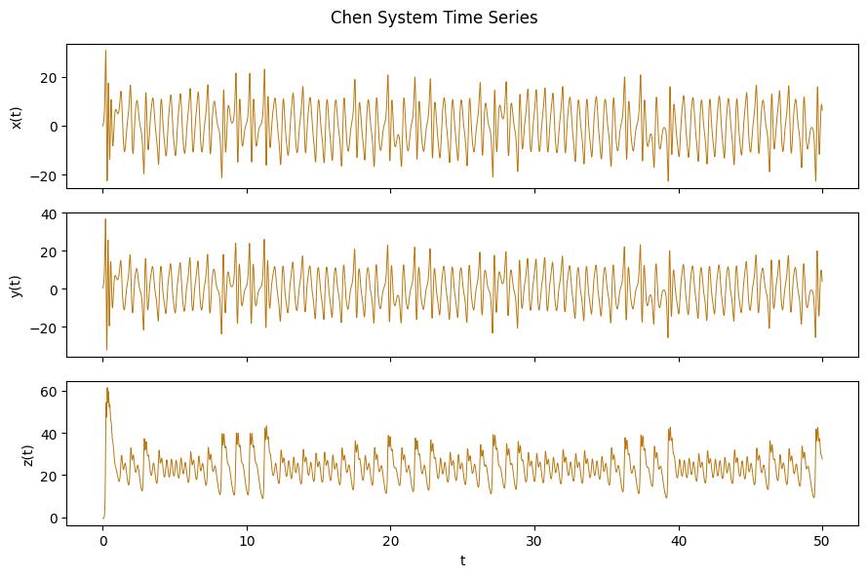The Chen attractor has a more complex structure than the Lorenz attractor, with trajectories moving rapidly between different regions. The time-series plots show irregular oscillations for all three variables, confirming that the system is chaotic. Small differences in the state variables continue to grow over time.

B.5 Hyperchaotic Rössler System
ẋ = −y − z, ẏ = x + a·y + w, ż = b + xz, ẇ = −c·z + d·w
Setting | Value
State variables | (x, y, z, w)
Parameters | a = 0.25, b = 3, c = 0.5, d = 0.05
Initial condition | (−10, −6, 0, 10)
Time step, dt | 0.01
Simulation length | T = 250
Solver | RK45 (SciPy solve_ivp, adaptive)
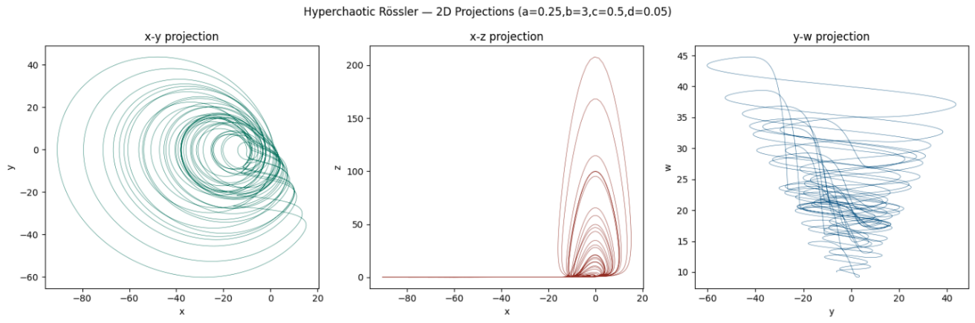
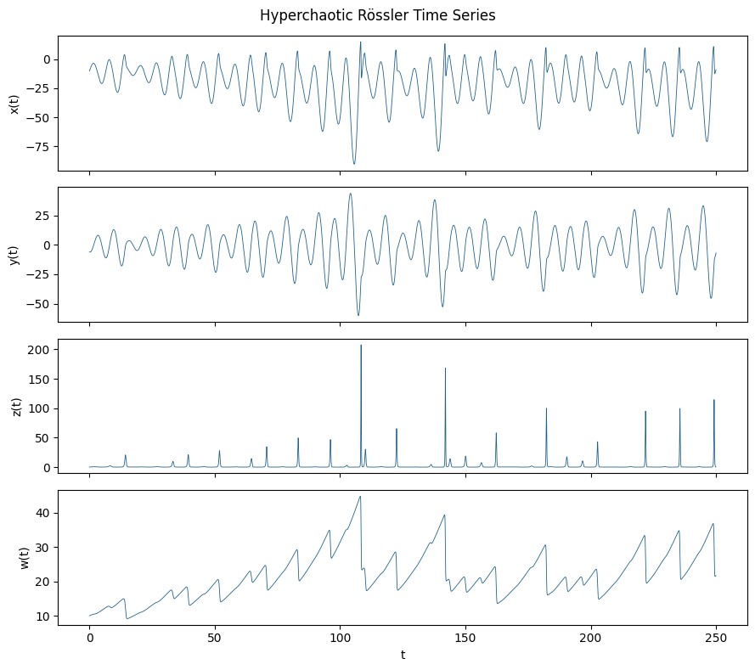
The Hyperchaotic Rössler system contains four state variables, so it cannot be displayed as one three-dimensional attractor. Instead, different two-dimensional projections are used to show its behavior. The time-series plots show that all four variables change continuously and irregularly, indicating a more complex type of chaos than the standard Rössler system.

Part C — Sensitivity Analysis

C.1 Parameter Sweep of the Lorenz System (ρ)
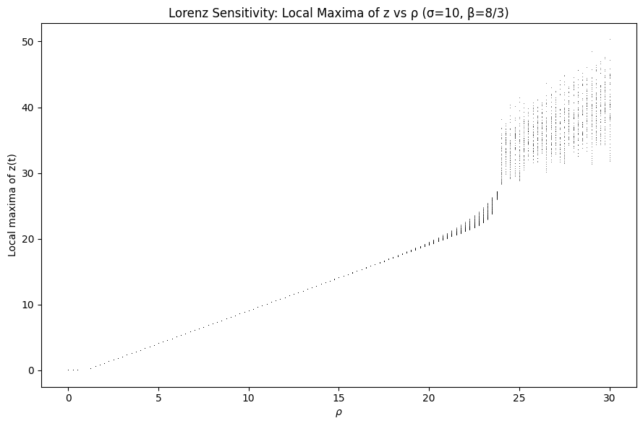
Changing the value of ρ had a clear effect on the Lorenz system. For smaller values, the trajectories were more stable, while larger values produced more complex and chaotic motion. This shows that even changing a single parameter can significantly affect the system's behavior. The parameter sweep demonstrates how sensitive chaotic systems are to their control parameters.

C.2 Step-Size Sensitivity
Setting | Value
Step sizes tested | dt = 0.001 (fine), 0.01 (baseline), 0.05 (coarse)
Fixed settings | σ=10, ρ=28, β=8/3; IC=(1,1,1); T=50; same solver
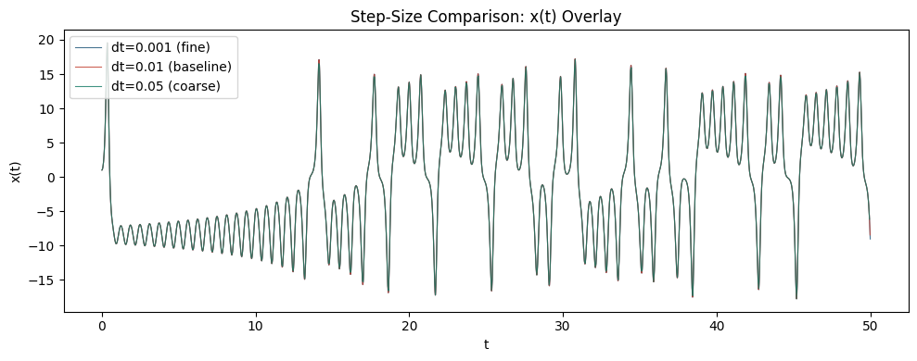
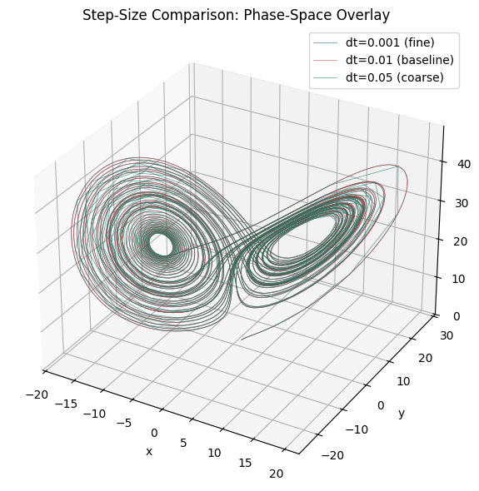
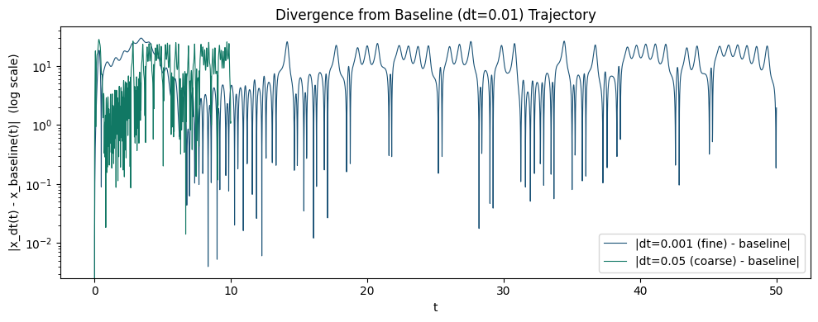
Different time steps produced different simulation results. The smallest step size (dt=0.001dt = 0.001dt=0.001) generated the smoothest and most accurate trajectory, while the largest step size (dt=0.05dt = 0.05dt=0.05) showed noticeable numerical differences. Although the overall attractor remained similar, the accuracy decreased as the step size became larger. This demonstrates that choosing an appropriate time step is important when simulating chaotic systems.

Conclusion
Discrete and continuous chaotic systems both show a transition from stable behavior to chaos, but they do so in different ways. The Logistic and Hénon maps change their state at each iteration, so their behavior is observed by changing a control parameter and examining the long-term values. The Lorenz, Rössler, and Chen systems evolve continuously over time by solving differential equations, and their behavior is analyzed from the trajectories and the parameter sweep results.

The Lorenz, Rössler, and Chen systems produce chaotic attractors that remain bounded while still showing unpredictable motion. The Hyperchaotic Rössler system is more complex because it includes a fourth state variable, producing more complicated trajectories that cannot be fully represented in a single 3-D plot. The step-size analysis also showed that even small numerical changes can cause the trajectories to diverge over time, although the overall attractor structure remains similar. These results demonstrate the high sensitivity of chaotic systems to both parameter values and numerical simulation settings.

